**Zendesk Standard Operating Procedure (SOP) For Daily Ticket Maintenance**

STEP ONE: UNASSIGNED TICKETS

When opening Zendesk, the very first thing is to check for any new “Unassigned tickets” from the Views Selection (The second selection down on the left-hand side blue vertical navigation bar). The new tickets are marked with a yellow box that has a black letter “N” and the boxes are to the left of each new ticket. New Unassigned tickets need to be replied with a “first time reply” within 1 hour of their Requested time.

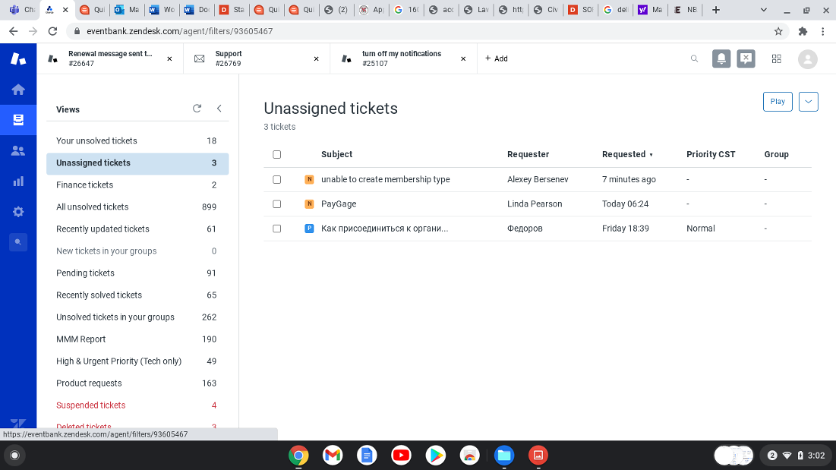

A first-time reply should begin with a standard introductory statement, such as “Hello (name of requestor), Thank You for contacting Glue Up Customer Support!”, followed by a statement of promise, or a request for more information from the ticket requestor, or an immediate solution to the ticket. A statement of promise says what is the next action intended by us, either to forward the ticket to another team such as the Tech Team, or to promise to research the ticket issue and respond shortly thereafter.

If they are non-English language tickets, there are standard first-time replies available in the “Macro” section located at the bottom of each Zendesk ticket in Spanish, Russian, Chinese, Portuguese, and one for Finance tickets. Just scroll through or type “first” in the search field for the appropriate Macro first-time response.

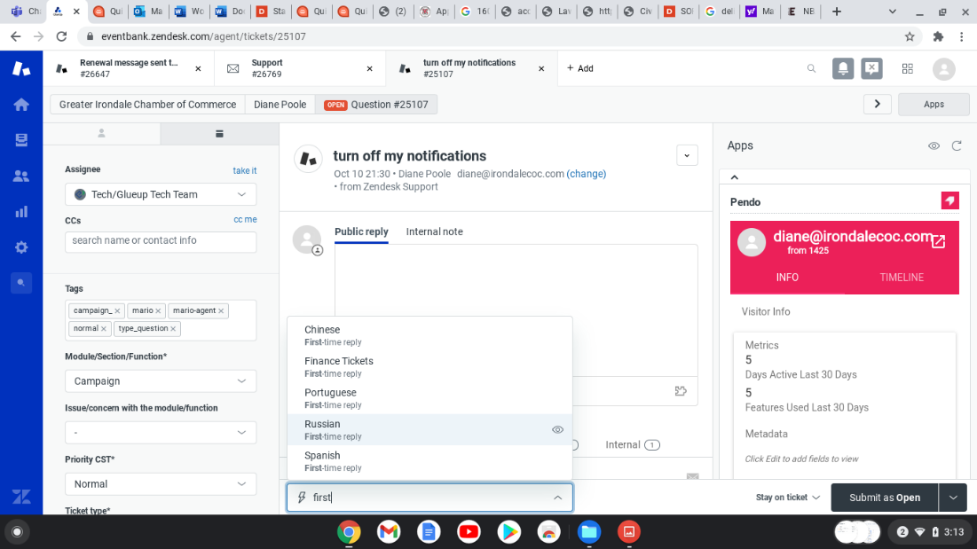

After the first-time reply has been added to the “Public reply” field, then a series of selections need to be made to classify the ticket. To the far left are a series of fields that have drop down menus and need to be filled out before the ticket can begin to be processed:

Assignee: Select the appropriate Team or individual who will be the next to handle this ticket.

Module/Section/Function: The portion of Glue Up that the requestor is having issues with.

Priority CST: This sets the priority level of the ticket and dictates the speed to which Teams should work to respond to and solve the ticket. There are three priority levels; Normal, High, and Urgent. Most tickets will be Normal priority. Reasons for High priority include time sensitivity, or financial sensitivity such as connecting a payment platform such as Paygage or Stripe to the customer Glue Up account. If there is a sense of customer anger or frustration, tickets may be elevated to High priority. Urgent priority should only be used if the customer is experiencing a problem with their Glue Up platform that is preventing them from doing business as usual, or if upper management has gotten involved to diffuse a sensitive customer situation.

Ticket Type: All tickets will be classified by one of 5 types; Question, Incident, Problem, Task, or Product Enhancement.

Assigned Staff Member Specification: A brief description of the nature of the ticket issue

CS Manager: The Customer Success person who is assigned to this client. If unknown, your name should go here.

Support Agent: The Customer Support Agent who is answering this ticket.

When the fields have been filled out, the ticket is now ready to be submitted. On the bottom right-hand corner is a gray box with a drop-down menu of selections:

Open: The ticket is being investigated by the Assignee.

Pending: Awaiting a response from the requestor of the ticket. Generally, if there has not been a response for a fixed amount of time, you may move to close the ticket.

Close: Once there is a solution provided and an acceptance by the ticket requestor, we can close the ticket. If the ticket is in “Pending status” and there is no response from the requestor for a fixed amount of time, we may close the ticket. If the ticket is a sales inquiry, we may close the ticket with the first-time response, usually “UNSUBSCRIBE” or something of that nature.

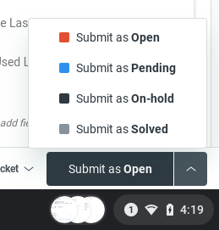

STEP TWO: YOUR UNSOLVED TICKETS

After Unassigned tickets have been assigned, the next step is to investigate your unsolved tickets. From the Views Selection, “Your unsolved tickets” will be at the top of the views list. Ideally, all the tickets in this section should be in “Pending” status, waiting for a customer response. Arranging them by date requested, and toggling between sorting them from oldest to newest, and then newest to oldest, allows for two actions to be taken: when viewing from oldest to newest, the fixed amount of time you have chosen to close unanswered pending tickets will allow you to start the day by closing those tickets that are oldest in your view in pending status. Then, by toggling the view to newest to oldest, you can see if there are tickets that have been answered by requestors and are now in “Open” status, or if tickets may have been re-assigned to you by another team and are also now in “Open” status. The open status tickets are marked with a red square and will stand out from the pending status tickets that are marked with a blue square. Open status tickets should be dealt with promptly, to either close them or to respond to their requestor with a solution and therefore put them back in “Pending” status.

To summarize, all the tickets in “Your unsolved tickets” should be in “Pending” status, and the blue pending tickets will sit in “Your unsolved tickets” view until either a response comes in to change them from pending to open status, or until enough time has passed for you to go ahead and close them. I use a standard macro for closing an unanswered ticket, with wording to the effect of, “Since we haven't heard from you, we will assume this issue is no longer a concern for you and we will be closing this ticket”.

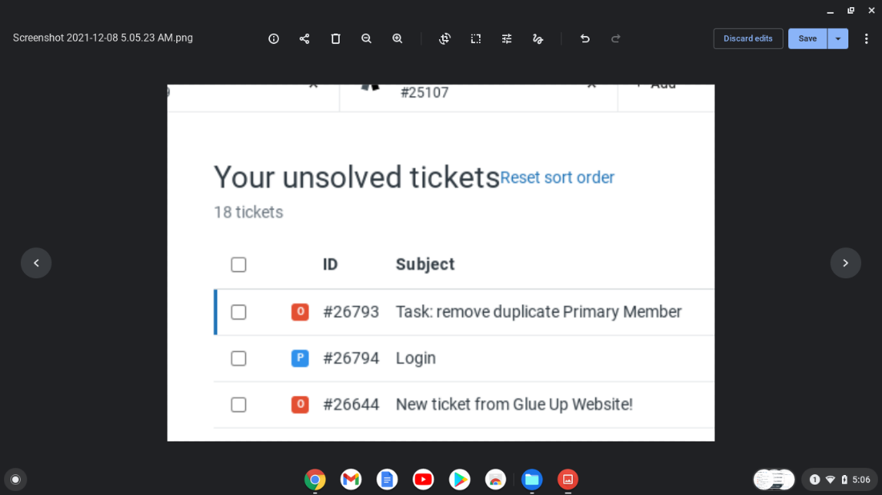

STEP THREE: PERSONILIZED VIEWS

There is an option to create personalized views in Zendesk, and this is helpful to track those tickets that were originally assigned to you but were transferred to another person or team. Those tickets have a habit of stalling from time to time, so I created a view to follow up on those tickets to make sure they are seen through to their completion.

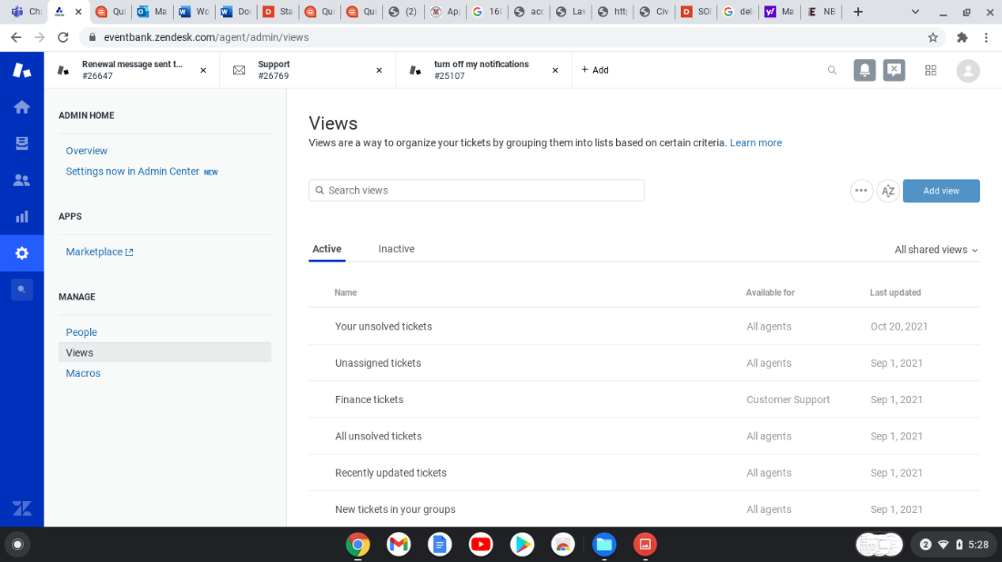

At the bottom of the Views left-hand side options, there is an option to “Manager Views” where you can create a personalized view to track the types of tickets I described, or any other sort of criteria.

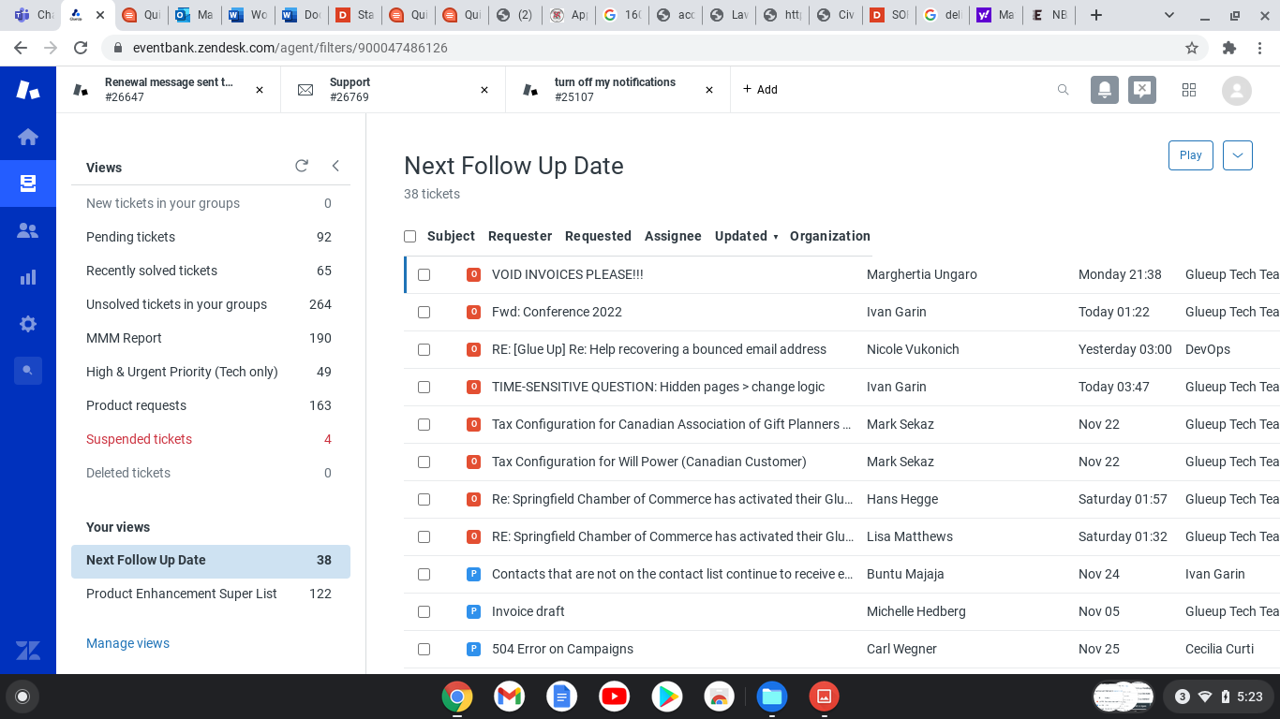

After a fixed amount of time, I will go into this view and select tickets to see if there aren’t any stalled tickets, waiting for internal communication between Glue Up teams that I can help to move forward.